**Jeen Chat – User Guide**



### 

**Introduction**

This guide explains how to work with the Jeen chat system, including available features and how to get the most out of working with agents. It contains step-by-step instructions and descriptions of screen elements and settings.

**Chat Structure**

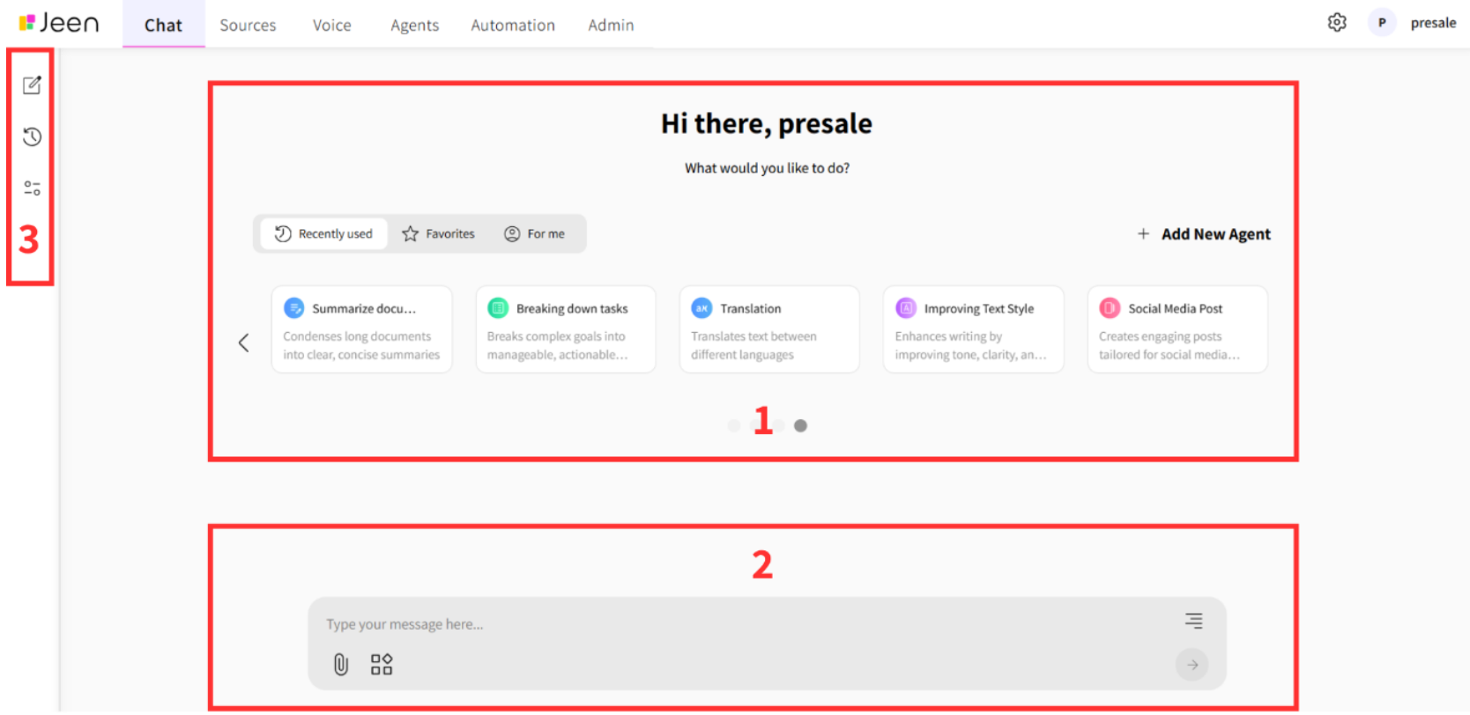

The chat interface is divided into three main components, numbered according to the image:

1. **Agent Carousel**  
    Allows switching between available agents. Clicking on an agent opens a chat with them. You can also create a new agent by clicking the “Add New Agent” button.
2. **Text Input Field**  
    This is where you type your message to the chat or agent. The field includes useful features such as:  
   * Attaching documents or images
   * Switching to Canvas to generate documents
   * A web search button to get updated answers beyond the model's built-in knowledge
3. **Sidebar Panel**  
    Includes buttons for accessing:  
   * Control Panel (chat settings)
   * Chat history (view or restore previous conversations)
   * Starting a new conversation

### **Text Input Field**

* Located at the bottom of the screen for free text entry
* Supports multi-line input with scroll for long messages
* Press **Enter** or click the send button to submit your message
* Messages are aligned based on the input language (Hebrew/English)
* You can align text left or right for readability

**Starting a New Conversation in an Existing Chat**

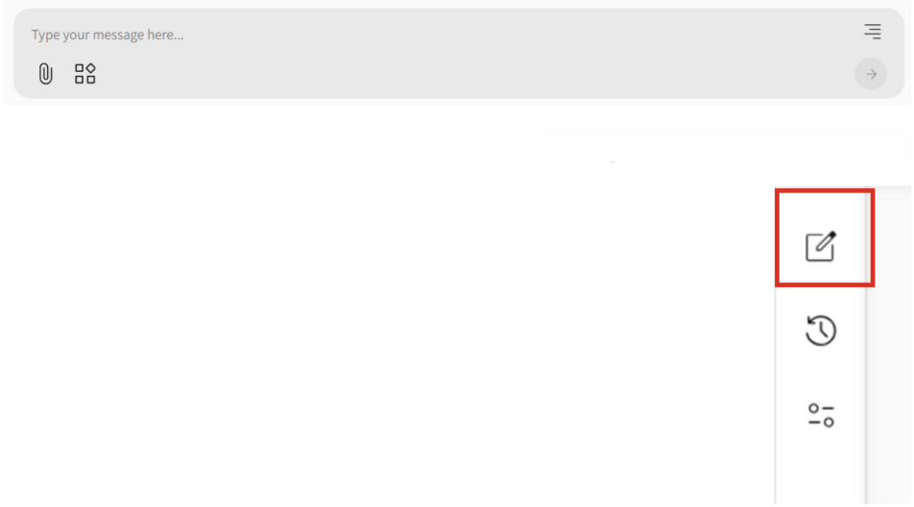

Click "New Chat" to open a blank chat window and begin a new interaction, unrelated to previous conversations.

**Actions on a Response**

After sending a message, the system displays a response from the model.

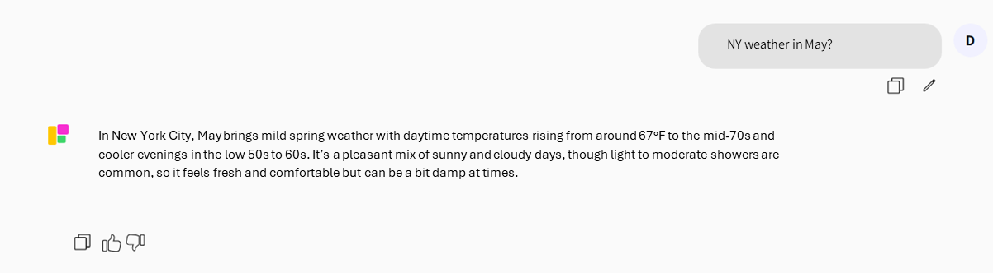

You can perform several actions on the received response:

* Give it a **like or dislike** to rate the quality of the answer
* **Copy** the response by clicking the copy icon
* **Attach additional files** to continue the conversation

### **Features in the Text Input Field**

#### **Attaching Files or Images**

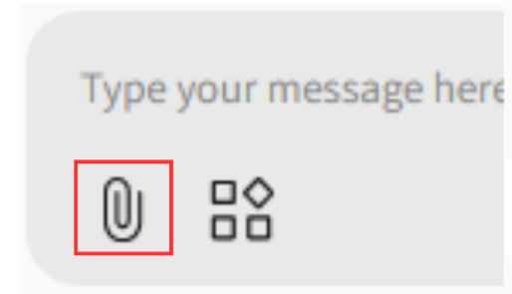

* Use the paperclip icon in the lower-left corner of the input field
* Allows attaching files or images to your message and asking questions based on the content (e.g., "Summarize this file" or "Describe this image")
* Supported formats: **PDF, DOC, DOCS, CSV, XLSX** *(Scanned documents are not supported)*

#### **Creating Custom Documents in Canvas**

* The **Canvas** button allows you to generate personalized documents  
   Examples:  
  + “Create a meeting summary”
  + “Generate a chart based on this Excel”
  + “Build a work plan”
* Documents can be edited manually or using the edit toolbar in Canvas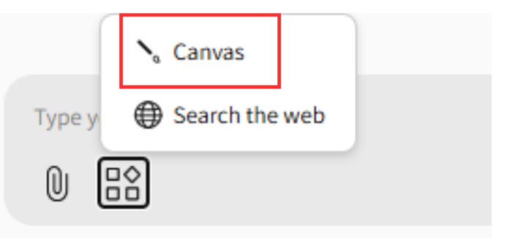

### 

### 

### 

### **ֿWeb Search**

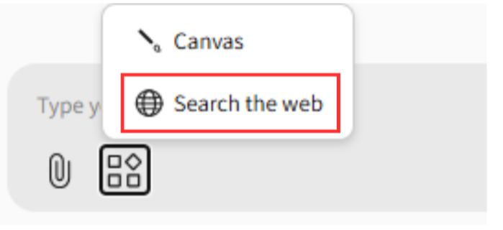

* The web search button lets the model access real-time data from external websites instead of relying solely on its internal knowledge
* When active, it appears highlighted and the response includes source links
* You can click on those links to view the original sources

### 

### **Agent Carousel**

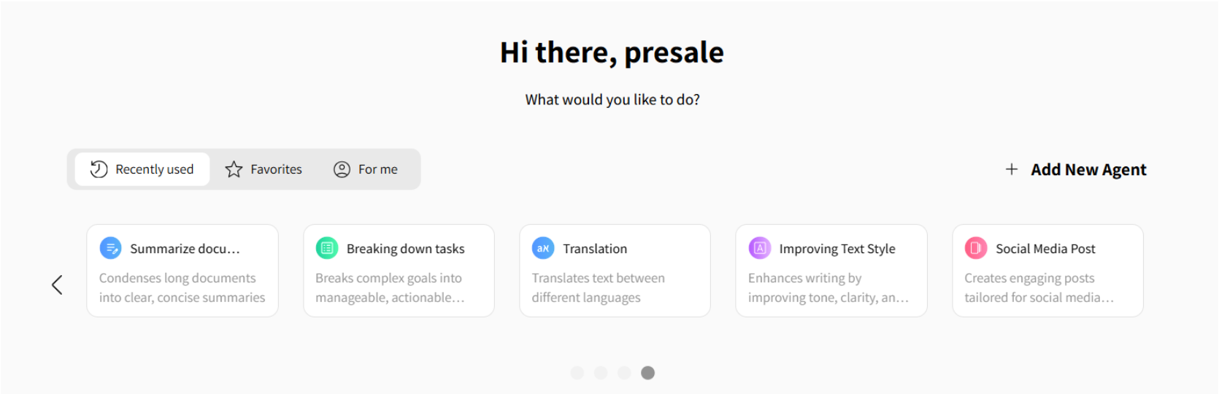

* Shows all AI agents the user has access to
* Each agent is powered by prompts, automations, and sometimes uploaded documents
* The agent receives your input and responds based on its defined behavior and knowledge base
* Use the arrow buttons to scroll through agents, view their names, and short descriptions of their purpose

### **Filtering Agent Display**

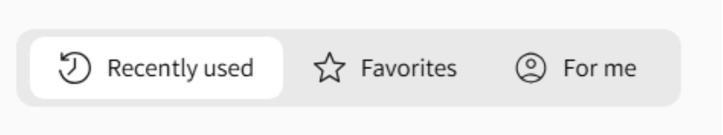

* **Recently Used** – Agents created by the user or shared by the organization, sorted by creation date
* **Favorites** – Agents marked with a star
* **For Me** – Agents assigned specifically to the user by an admin

### 

### 

### 

### 

### **Agent Card Actions**

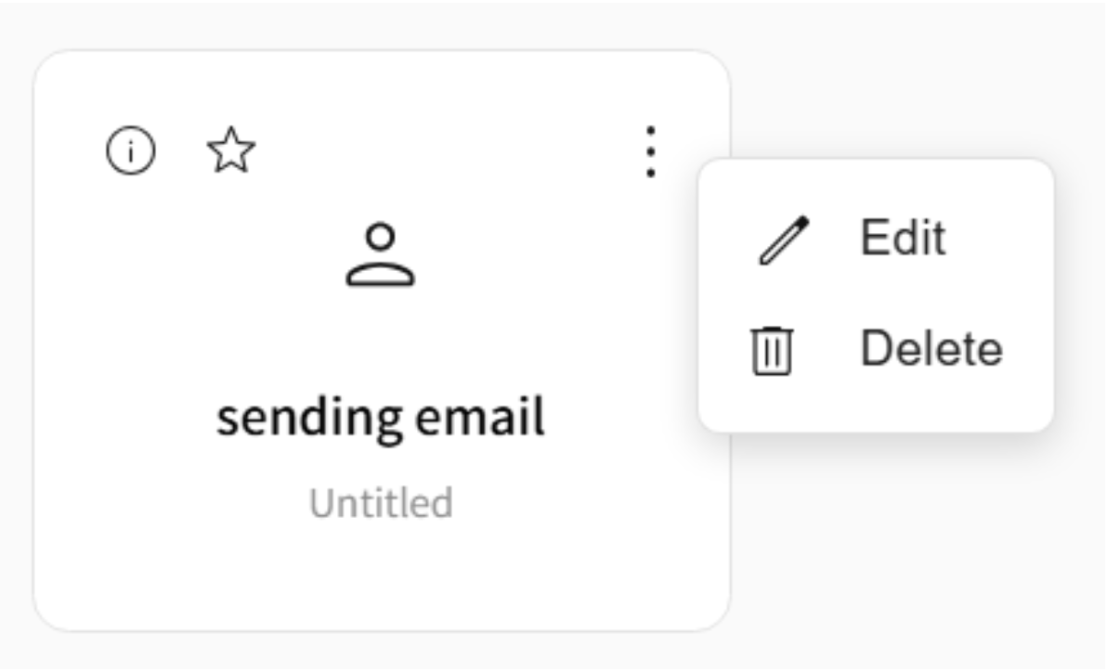

* **Star icon:** mark the agent as favorite
* **Info icon:** shows creation and last updated date
* **Three dots menu:** edit agent details, change model, or display settings
* Clicking on an agent shows its built-in welcome message and describes its use case

### **Interacting with an Agent**

* Type messages in the input field at the bottom
* The response will be based on the agent’s prompts, documents, automations, and settings
* You can use all input field features during the conversation:
  + Canvas button for documents
  + Attachment icon
  + Web search for updated info

### **Switching Agents During a Conversation**

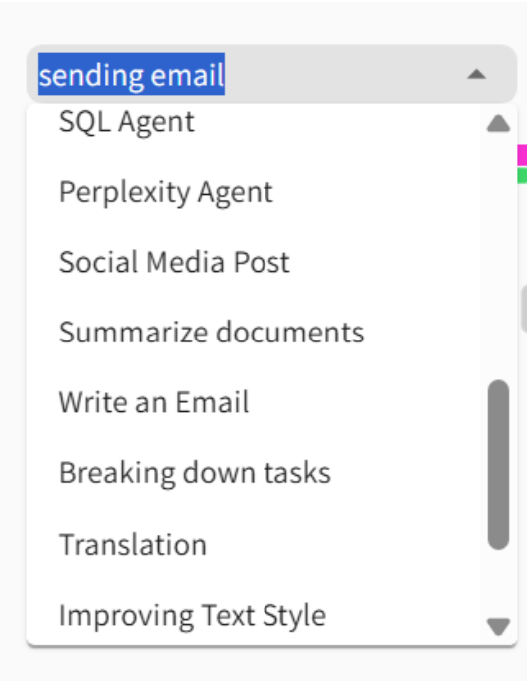

* You can switch to a different agent mid-conversation using the agent list
* The new agent’s welcome message will appear in the chat
* Context is preserved: for example, if the previous agent created a social media post, you can ask the new agent to draft an email with that post's content

### 

### 

### **Additional Agent Actions**

* In the top-right of a conversation, there's a button to start a new chat with the same agent

